SIMATS ENGINEERING (SAVEETHA SCHOOL OF ENGINEERING)
Department of Computer Science and Engineering
ASSESSMENT TOOL 3 – INDIVIDUAL TALK

Course Code: | ITA0301 | Course Title: | Mobile computing
CO Assessed: | CO1 | Assessment: | Assessment Tool 3 – INDIVIDUAL TALK
Weightage: | 30 % of CIA | Total Marks:
CO1 Statement: | Analyse the mobile network components, mobile base station, mobile infrastructures and protocols in cellular systems.
Student Name: | M GOKUL RAJ | Reg. No.: | 192521494
Section / Batch: | BTECH-IT(2ND Year) | Date: | 10/10/2026
Code of Conduct
I M.GOKUL RAJ(19251494) certify that this submission is my original work and that I have adhered to the guidelines specified for this assessment. I understand that any violation of academic integrity rules will result in disciplinary action.

Signature of the Student: GOKUL RAJ
Instructions
- Topic given before the session and students speak on stage.
- Duration: 10 minutes (In class)

Faculty In-charge | Course Coordinator | Program Director
Signature: | Signature: | Signature:

Date: | Date: | Date:

Individual Task: HANDOFF IN CELLULAR SYSTEM
1. Introduction
Handoff (or handover) is a process in a cellular communication system in which an ongoing call or data session is transferred from one cell or base station to another without interrupting the communication.
It helps users maintain continuous connectivity while moving from one location to another.
2. How Handoff Works
Handoff takes place through the following steps:
- Signal Monitoring: The mobile device and network monitor signal strength and quality.
- Handoff Decision: When the signal from the current base station becomes weak or another cell provides a better signal, the network decides to initiate a handoff.
- Resource Allocation: The target base station allocates the required radio channel or resources.
- Connection Transfer: The mobile device switches its connection to the new base station.
- Completion: The old connection is released, and the call or data session continues through the new cell.
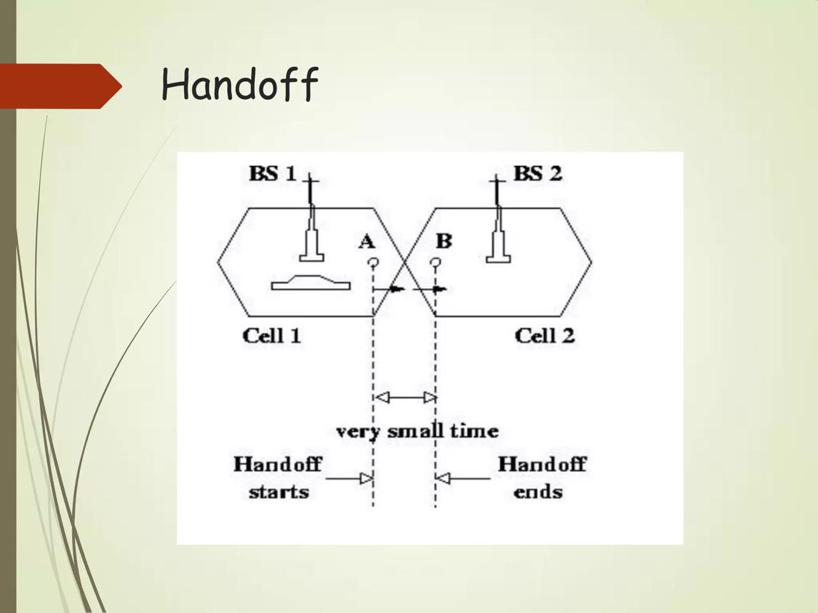
3. Technologies Used
The main technologies and methods used in handoff are:
- Signal Strength Measurement: Measures the strength of signals from nearby base stations.
- RSSI (Received Signal Strength Indicator): Indicates the received signal power.
- Handoff Algorithms: Determine when and where handoff should occur.
- Mobile Switching Centre (MSC): In traditional cellular systems, coordinates call transfer between base stations.
- Radio Resource Management: Allocates and manages radio channels during handoff.
- GPS and Network Measurements: May assist in identifying location and selecting suitable cells.
4. Applications
Handoff is used in various situations, such as:
- Voice Calls: Maintains calls while users move between cells.
- Mobile Internet: Supports continuous data connectivity.
- Vehicle Communication: Keeps mobile devices connected while travelling.
- Public Transportation: Supports connectivity on buses and trains.
- Emergency Communication: Helps maintain connectivity for users moving between coverage areas.
5. Advantages
- Provides uninterrupted communication while moving.
- Improves network coverage and connectivity.
- Reduces the chances of dropped calls.
- Supports user mobility.
- Improves the utilization of network resources.
- Enables continuous voice and data services across multiple cells.
6. Challenges
- Dropped Calls: Handoff failure may disconnect an ongoing call.
- Handoff Delay: Switching between cells can cause temporary interruptions.
- Ping-Pong Effect: A device may switch repeatedly between two cells.
- Limited Resources: The target cell may not have enough available channels.
- Interference: Signals from nearby cells may affect communication quality.
- Complexity: Handoff decisions become more difficult in dense networks and high-speed mobility.
7. Conclusion
Handoff is an essential feature of a basic cellular system that allows mobile users to move between cells while maintaining ongoing calls and data sessions. By monitoring signal quality and transferring connections to suitable base stations, handoff improves mobility, coverage, and communication reliability. Efficient handoff management is important for providing seamless cellular services.

Geotag Photo:
